# 5. Novel methodology for producing amorphous ice micro-particles

## 5.1. Overview and aim

Bulk properties of amorphous ices upon collisions is assumed to be less elastic than crystalline ice (Wang et al. 2005), thus providing a potential solution to overcoming the bouncing barrier for grains around cm size. However, collision properties of amorphous ice coated grains relevant to those found in the midplane of protoplanetary disks has never been investigated. This is due to the difficulty to produce, use and store such samples that are metastable under Earth conditions.

ASW is commonly produced by water vapor deposition on a cold plate up to few monolayers (ML) due to the heat of condensation that needs to be transmitted into the cold surface. Bar-Nun overcame this issue by scraping the surface when the sample was 200 µm thick with a cold knife, introducing it in a sample container maintained at Liquid nitrogen temperature thus, producing 5- 10 cm thick samples (Bar-Nun and Laufer 2003). This method has been used to study the bulk properties of comets but is not suitable to produce pebble like samples, necessary to perform collisions.

Another way to produce vitreous ice involves rapid freezing (quenching) from the liquid phase, where the size and shape of the frozen sample, named Hyperquenched Glassy Water (HGW), is determined and controlled by the initial liquid droplet. HGW and compact ASW have similar properties (citations) and thus can be considered good analogues of each other. However, water is a poor glass former and consequently, needs a very fast cooling rate to be vitrified, typically of the order of 106 K/s (citations).

Brüggeller and Mayer (1980) were the first to achieve the complete vitrification of water droplets by spraying them into organic cryogenic liquids. This technique has since been improved by cryo-biologist intending to freeze living samples to be seen in Electron microscopy while avoiding artefacts due to crystallization and have been awarded the Nobel prize in chemistry in 2017 (Dubochet and McDowall 1981).

I aim to adapt this method in order to produce µm amorphous ice grain for Astronomical purposes. The range of application is extremely broad, spanning from microgravity collision experiments to decipher the processes of planet formation, to the determination of optical constants of 3D amorphous ice, a key aspect to process future JWST Data (citations).

In this chapter I will describe two experiments that I have designed to produce ASW grains; a proof of concept will be discussed first in section 5.3 before going on to describe the second version in section 5.4 and its procedure in section 5.5. A brief Introduction to the theory of cooling and an evaluation of both experiments will be respectively debated in sections 5.2 and 5.6.

## 5.2. Theory of cooling

(in progress 🡪 no correction)

### 5.2.1. Nucleation theory

If one wants to produce a vitreous sample, crystallization must be avoided. Crystallization resulting from the supercooling of a liquid occur in 2 steps, nucleation and consecutive growth (explain each better)

Nucleation processes can arise from two sources. If it is induced by a foreign particle or surfaces 🡪 Heterogenous nucleation. Water molecules combining to form “embryo” relate to homogeneous nucleation (Homogeneous nucleation temperature Th) 🡪 Have to overcome a free energy barrier?

Heterogeneous nucleation is faster than homogeneous nucleation 🡪 Need to be avoided 🡪 **Sample of small sizes diminish the presence of foreign particles thus improving the chances of vitrification**

Th (homogeneous nucleation Temperature) 🡪 Decrease with increasing cooling rate

Glass transition temperature (Tg) 🡪 When T lower, molecular mobility slowed down 🡪 no structural changes

Nucleation process releases energy thus leading to a local Temperature increase of the sample

Crystal growth depend on the balance between heat production and heat dissipation

cryogen thermal conductivity

Liquid glass formation depends on crystallization kinetics (nucleation frequency and crystal growth rate) 🡪 Check Avrami and the rate at which the liquid is cooled.

* Nucleation rate (J) 🡪 approximate method 🡪 seeding
* Crystal growth (u)

Dynamics of quenching (Angel and Choi 1986) 🡪 to check (Angell and Choi 1986)

τ in , internal relaxation time τ out , escape time

τ out initially decreases due to the building of the thermodynamic driving force (G cryst - G liquid)

τ nose , in τ out curve result arise from competition between driving force and molecular mobility (τ in)

🡪 minimum of crystallization time need to be bypass to avoid crystallization.

### 5.2.2. Cooling rates and Mechanism of heat dissipation

Water properties 🡪 Reduced temperature (T boil \ T mel) < 2 (1.37) 🡪 poor glass former

Cooling rate estimation: Turnbull 1969 🡪 To check (Turnbull 1969)

Biot formula :

$$Nu= \frac{h×d}{k_{s}}$$

h is the effective heat transfer coefficient

d is the effective dimension

ks is heat conductance of the specimen

thermal properties 🡪 highly dependent on temperatures

Forced convection / conduction

Overview different cooling exp

### 5.2.3. Cryo-liquid comparison

Difficult to measure the heat transfer physical processes as many parameters have to be taken into account and measuring instrument influence the cooling process.

Ie, thermocouple, metals don’t have the same cooling properties as water, influence the cooling process …

From previous, important parameter for cooling that relate to cryoliquid properties are …

Table with different cryogen compared !!

|  |  |  |  |  |  |  |  |
| --- | --- | --- | --- | --- | --- | --- | --- |
|  | Tliquid (K) | Vapor pressure (mbar) | viscosity | Thermal conductivity () | Heat transfer coefficient h () |  | Excessive vapor formation |
| Liquid Nitrogen |  |  |  |  |  |  |  |
| Methane |  |  |  |  |  |  |  |
| Ethane |  |  |  |  |  |  |  |
| Propane |  |  |  |  |  |  |  |
|  |  |  |  |  |  |  |  |
| Butane-1-ene |  |  |  |  |  |  |  |
|  |  |  |  |  |  |  |  |
|  |  |  |  |  |  |  |  |

Ethane, propane, butane-1-ene investigated by …

Ethane has a similar cooling rate to propane (2.6 \* 105 K/s) but a lower Boiling point (184 K vs 231 K), which makes it less likely to leave any residue in the vitrified samples (47). It is our aim to adapt this method to produce HGW particles for laboratory astrophysics and planet formation experiments and this will be described in the following sections.

## 5.3. Proof of concept experiment

The overall aim of this experiment is to produce and introduce µm size water droplets into a liquid cryogen maintained at cold temperature to vitrify them similarly to the spray-freeze-etching method developed by Bachman (Bachmann and Schmitt 1971) with the difference that ethane is used as cryogen and not propane, as being done by Mayer (Mayer and Brüggeller 1982).

Water droplet production 🡪 3D spherical samples.

Cryo-SEM sample preparation usually requires cooling of a sample holder (holding the sample) (citation), to be subsequently introduced into the microscope without further manipulation. The method used in this proof of concept experiment work towards direct freezing into the cryogen of a large number of samples (calculation of number of individual µm droplets from 10 ml), prior to storage in liquid nitrogen for future manipulation or characterization. This imply the design of a “recovery method” to retrieve and separate the water ice particles from the cryogen (liquid ethane).

### 5.3.1. Safety consideration

Ethane is a flammable gas and for that reason, the experiment has thus to be handled in a Glove Box (GB) to avoid the dispersion of ethane into the laboratory. The glove box is continuously purged with dry nitrogen gas to decrease the amount of oxygen, thus getting below the lower flammability limit of ethane, 3 % at atmospheric pressure (Le, Liu, and Mannan 2013). This also prevents contamination of water moisture from the atmosphere, which is necessary as some of the experiments are performed using heavy water (D2O). I have also taken the utmost care to minimize potential spark sources by having no electrical devices within the glove box and earthing all the outer metal parts. Also, the gloves are made of butadyl, a static dissipative material. Overall, after filling a Sevron Risk Assessment RA816548 (Annex?), the risk is evaluated as low.

### 5.3.2. Design and operation

Figure 1 shows the overall proof of concept experimental setup, which will be described in detail in this section, together with the detailed experimental procedure and the order of operation. The main experimental is divided into 4 steps, represented by the different colored rectangles in Figure 1:

* Ethane liquefaction (green)
* Water droplet production (dark blue)
* Water droplet introduction (light blue) and
* Sample recovery (red)

Each of these steps will be described in turn in the following paragraphs, but first a general description of the experimental set up is given, together with details on setting up the ideal working environment within the glove box.

The glove box is divided into two parts, the main chamber P1 and an airlock chamber P2. P1 is the main working space and contains the reaction vessel (indicated with the green square containing parts labelled 1, 2, 3 and 4) and the recovery dewar (highlighted in light red, DR). P2 is a self-contained chamber connected to P1 via an air-tight door the purpose of which is to extract the recovered sample (DR) without releasing too much ethane into the laboratory. P1 has a bolted front door, that can allow all the material needed to be put inside the glove box (list of the material) prior to beginning of the experiment.

Both chambers are purged with nitrogen gas from the same gas cylinder, with its pressure set via a two-stage gas regulator at 0.2 bar (Value to check – Do I speak about Extraction 🡪 ¼” pipe - Carbon trap? – main lab exhaust). 30 minutes of purge is necessary to decrease the O2 levels in the main chamber below the 3% representing the lower flammability limit of ethane. To monitor the oxygen levels while purging, a portable oxygen alarm is introduced into the glove box.

Once the initial purge is achieved the N2 flow is decreased to provide good working conditions, for example, a pressure set up too high will inflate the gloves thus reducing handling abilities within the glove box. However, a small nitrogen flow needs to be present at all time, maintaining a slight overpressure and preventing any air (containing O2) from entering the glove box.

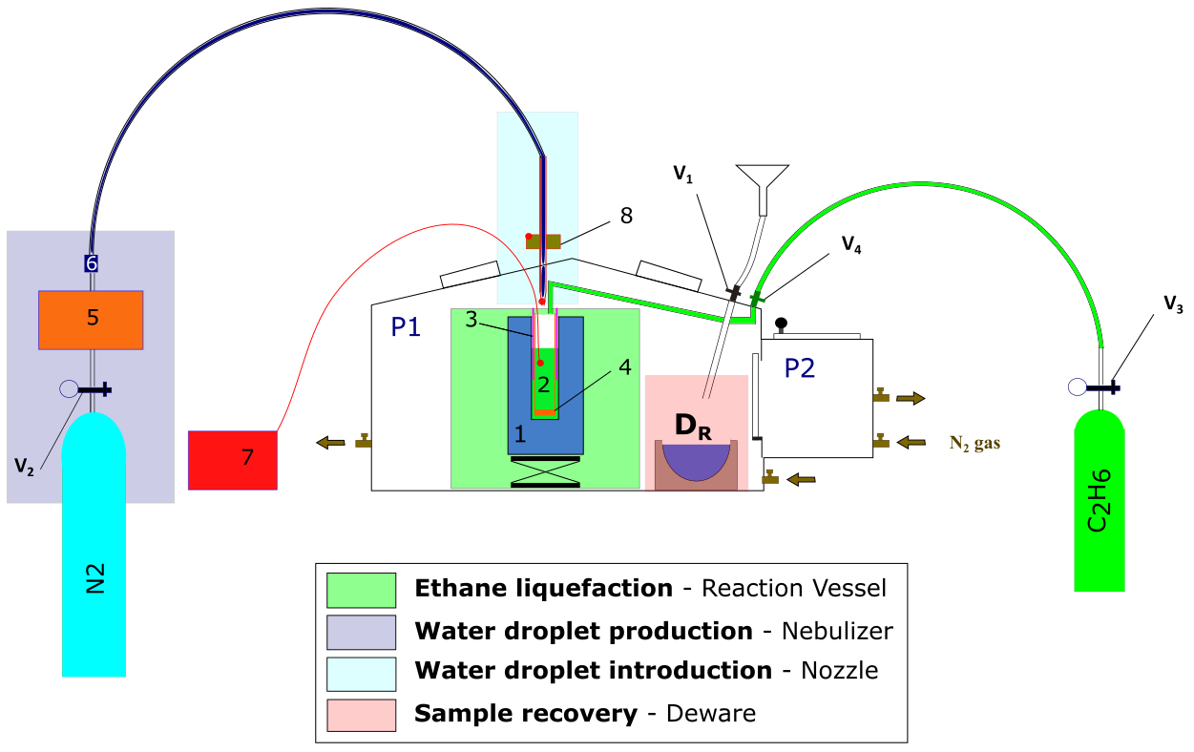

**Figure 1:** Diagram of proof of concept experiment. Colored squares represent the different setups associated with the different part of the procedure; green: ethane liquefaction; dark blue: water droplet production; light blue: water droplet introduction; red: sample recovery and transfer. Numbers will be explained later in the text.

The only time when the purge is stopped during the procedure is when liquid nitrogen needs to be introduced inside the Glove box, a preliminary step before ethane liquefaction and sample recovery. The reason being that when poured in a warm container, (1) in Figure 1 and 2, liquid nitrogen evaporates quickly with a liquid to gas ratio 1:694 (citation).

Liquid nitrogen is taken from a pressurized Dewar, filtered using a tea towel into a polystyrene container (2L volume) and brought to the lab. A funnel (right corner of P1), connected to the glove box via a cryogenic ball valve (V1) is used to introduce the liquid nitrogen. A plastic tube (material 10 cm long) is connected to the valve inside the glove box to channel the liquid into the Dewar flask.

Once the N2 purge is temporary paused, pressure must be applied on the gloves to decrease the overall volume of the glove box. A small amount of liquid nitrogen can then be poured into the funnel (V1 being closed). This can lead to some turbulent outpouring resulting from the initial cooling of the funnel and appropriate PPE (Personal Protective Equipment) must be worn at all times. Also, some bubble wrap and tea towels are disposed around the funnel preventing falling liquid nitrogen to get in contact with the glove box walls. V1 can then be opened and liquid Nitrogen introduced into the Dewar. Because of the Dewar being initially at room temperature, most of the liquid Nitrogen will evaporate, increasing the pressure within the glove box. Deflating the gloves and stopping the purge before introducing the liquid nitrogen allows for control of gas volume within the glove box. Indeed, the evaporating liquid nitrogen will first result in the glove inflation, thus counterbalancing the temporary increase in pressure. If too much LN2 is initially introduced into the funnel, the gloves will inflate fully thus increasing the pressure inside the glove box, preventing the liquid to flow through the valve. This can represent an explosion hazard that must be prevented by filling the Dewar (1) gradually, and not introducing too much nitrogen in the funnel each time, particularly at the beginning of the experiment where everything is warm. Before every funnel refilling with nitrogen, it is important to make sure that the gloves are fully deflated by pressing on them with V1 open. This operation must be patiently repeated 4 times to fill the 1L Dewar (1).

#### Ethane liquefaction

Ethane is commercially available as gas (CAS info etc, where do I get it from 🡪 need to ask Tom on return, proper licensing is needed to get access to ethane delivery).

What kind of regulator, Ethane acheminated through a 1/8“ pipe, flashback arrester to avoid reflux of gas inside bottle 🡪 safety.

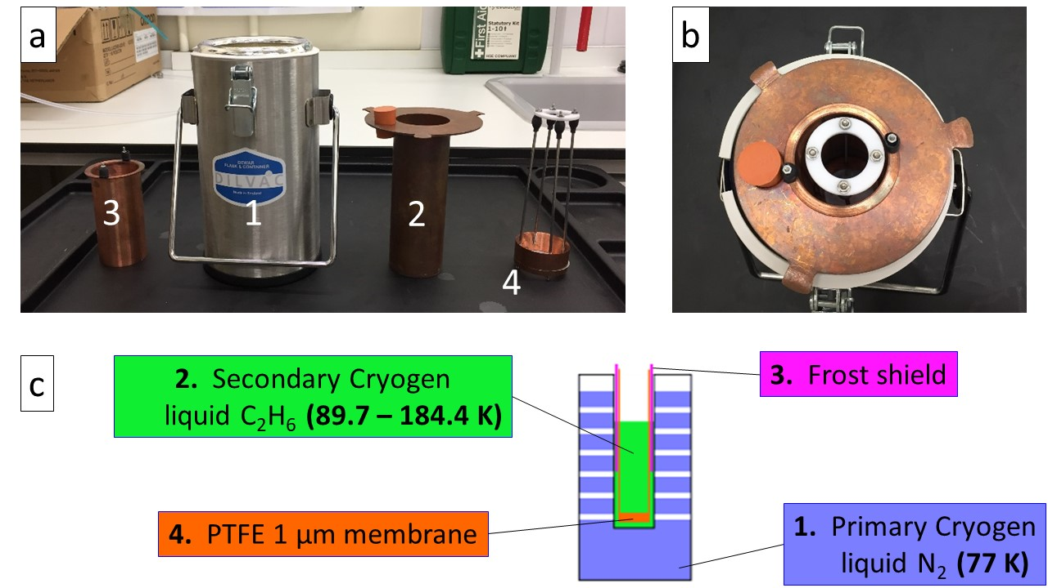

**Figure 2**: a) Separate pieces of cooling setup: (1) Dewar vessel, liquid N2 bath – primary cryogen (2) Custom reaction vessel for C2H6 – secondary cryogen (3) Frost shield (4) basket – PTFE 1 µm membrane; b) Assembled cooling setup; c) Schematic diagram of the cooling setup

Ethane is liquid between 89.7 K and 184.4 K at atmospheric pressure (citation). Liquefaction is achieved by introducing ethane gas in a reaction vessel (2), cooled to 77 K by submersion in liquid nitrogen contained in (1). (3) is a frost shield, the purpose of which is to catch frost that inevitably grows from the water vapour present within the glove box (even with the purge on), sticking on the cold metal parts of the reaction vessel (2). This is necessary to prevent frost from falling into the cryogen, as this would be a source of impurity. (4) is a PTFE membrane containing 1 μm sized pores, screwed at the bottom of a custom-made basket that is used to fish out the particles from the cryogen. (2), (3) and (4) are made of copper, a high thermal conductive metal (thermal conductivity of 401 W/m/K at 273K (citation – value taken from Wikipedia)), allowing for efficient thermal transfer. They must be put in place as shown in Figure 2 (b) prior to the initial cooling phase, basket (4) being introduced first followed by the frost shield (3). Because they are made of the same material (copper), mechanical stress due to differential shrinking resulting from exposure to cold temperature is prevented.

Once (1) is filled with liquid nitrogen as described previously, (2) is slowly submerged into (1) to progressively cool it down. This part of the procedure can be quite time-consuming (10-15 min) and posing risks because cooling (2) greatly enhances nitrogen evaporation which in turn increases the pressure within the GB inflating the gloves. I overcome this issue by holding and dipping the reaction vessel with one hand inside the glove box while keeping my other hand out in order to externally open or close V1 to release the overpressure. Cryogenic gloves must be worn inside the glove box (over the top of the glove box gloves) to prevent injuries from prolonged contact with cold temperatures. Cooling of the reaction vessel at liquid nitrogen temperature (77K) is identified by an intense evaporation event (Leidenfrost effect?), followed by the liquid nitrogen becoming quiescent. This phase usually results in the evaporation of most of liquid nitrogen which can be topped up in (1), to no more than 2/3 of the level to account for the volume of the reaction vessel.

Once the reaction vessel is at liquid nitrogen temperature 77K, ethane gas is introduced into (2) via a movable copper pipe from the ethane gas bottle fed through the glove box via the valve (V4). This is done by first, opening the gas bottle, followed by the gas regulator and finally the valve V4. Ethane pressure is monitored using a digital pressure gauge which is connected between the gas regulator and V4.

The ethane introduction is characterized by the appearance of a thick fog of ethane microdroplets within the reaction vessel (as shown in figure 15 – figure is far away but don’t have similar picture with this setup … - bringing figure 15 here could create confusion between the two experiments). This fog is strongly influenced by the incoming ethane gas flow. Indeed, an ethane pressure set up too high will result in turbulent convection into the reaction vessel blowing out from it most of the liquid droplets, thus reducing the liquefaction efficiency.

To achieve ideal flow conditions, ethane pressure is adjusted using the regulator to around 100 mbar to achieve a smooth introduction as shown in Figure 15 b).

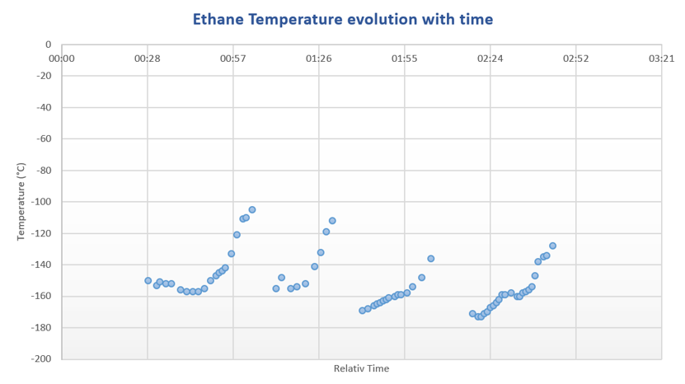

**Figure 3:** Ethane temperature vs time during the ethane liquefaction phase

A K-type thermocouple is attached to the frost shield (3) to monitor the ethane temperature and is shown in Figure 3. The liquid ethane temperature is not stable and constantly increases because the cooling setup never reaches a state of equilibrium. This is due to the constant evaporation of the primary cryogen, liquid nitrogen, since its boiling temperature, 77 K is lower than the melting point of ethane, 89.7 K. It is therefore necessary to refill the liquid nitrogen in (1)every 30 minutes. (2) needs to be lifted out of (1) and carefully re-inserted once (1) is refilled. This procedure must be repeated 4 times (as can be seen in Figure 3) until the desired amount of liquid ethane has been reached corresponding to ¼ L, or a filling level 2 to 3 cm below the top of the reaction vessel. This operation takes 2 hours to be completed. Before the next step, where water droplets are introduced into the cryogen, liquid nitrogen can be topped up as necessary if the temperature is too high. The ethane pipe has to be removed from inside the reaction vessel, with its height adjusted with a lab jack to move it closer to the nozzle.

#### Water droplet production and introduction

Two goals need to be achieved regarding the water droplet production. First, the droplets must be small, in the order of a few micrometer to perform an optimal vitrification (Explain why – fewer chances of getting impurity – reduce chances of impurity per droplets, sources of heterogeneous nucleation, also smaller sample will cool quickly). 🡪 What is the purity of the water used? – triple distilled water?

🡪 Cleaning procedure, can the droplets get impurity from their way towards the cryogen …

Secondly, they need to be introduced at relatively high speed to be deeply embed in the cryogen thus improving the forced convection thermal transfer (source).

Both of those objectives can be achieved using commercially available nebulizers. Those devices are commonly use in drug delivery to lungs (Why? 🡪 source). Droplet size relate to alveolar absorption …

Liquid nebulization is achieved by the application of a dispersing force on a liquid or solution. The dispersing force can be of two sources, a jet of gas (from air pressurization through a compressor) or ultrasonic waves, leading to two main family of nebulizer devices (jet or ultrasonic).

Ultrasonic Nebulizers gives a higher MMAD (Mass Median Aerodynamic Diameter) with respect to jet nebulizers (source). A peculiar feature of jet nebulizers is that they tend to cool down the water in the sample container during the nebulization process (source).

I have chosen to use a commercially available compressor nebulizer, Phillips Innospire Deluxe. It is made of a compressor (maximum working pressure 3.6 bar), pumping the air and producing a high velocity flow through a liquid sample container (10 ml), producing an aerosol (Explain better 🡪 water channeled through 4 capillaries, broke up by jet flow, baffle retain big particles and smaller particles aerosol channel out of water container).

I have adapted the nebulizer to use nitrogen (N2) as a carrier gas rather than the ambient air and the benefits are three-folded. It prevents the introduction of both water (an impurity when D2O is used) and oxygen (a catalyst in an explosive atmosphere). The N2 flow is also an adjustable parameter to influence the nebulization process (cf. Figure? 🡪 Chapter 6-7 – microscope pictures). We have blocked all the sources of auxiliary flow; The mouthpiece has been replaced by a plastic pipe that connects to the water container via a custom-made PTFE connection. An O-ring (shown in red in figure 4 (c) is inserted so that the system is completely airtight. (what is the effect on nebulization process?)

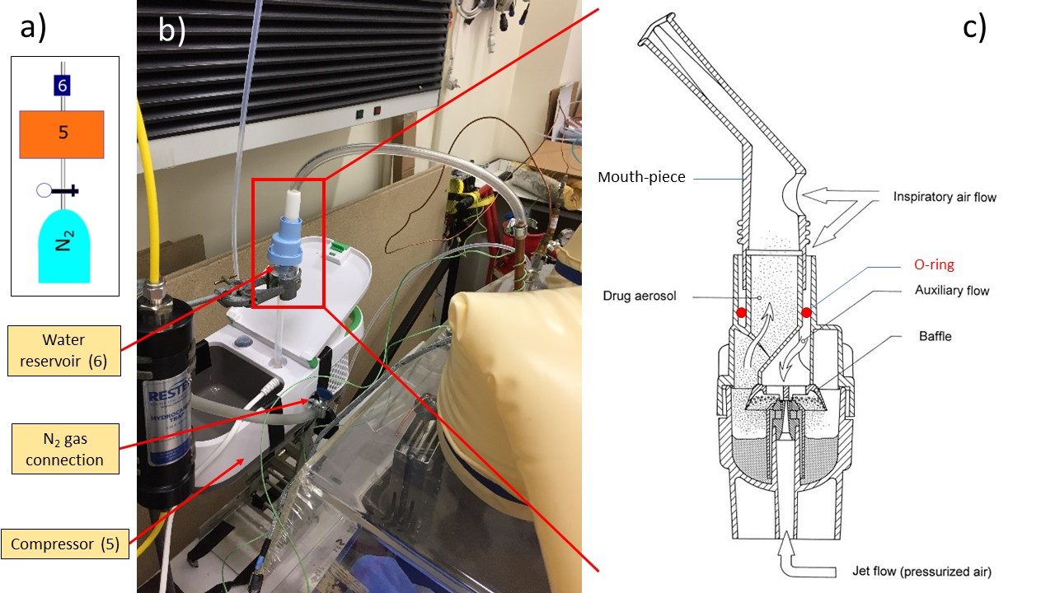

**Figure 4:** Nebulizer setup a) Capture of the setup from Figure 1; b) Picture of the compressor nebulizer; c) Diagram of the Sidestream technology atomization setup taken from (Lebrun 2000)

The droplets are introduced into the cryogen via a nozzle made of copper fed through the glove box. The geometry of the plastic pipe between the water reservoir and the nozzle needs to be carefully adjusted to reduce droplet condensation on the pipe wall. Even though this condensation effect can be reduced, it is not possible to completely prevent it. This can result in big size droplets falling into the cryogen and that needs to be prevented at all cost. Small droplets forming on the inner walls of the pipes are usually transported by the gas flow and build up on the nozzle orifice. It is then possible to manually absorb them using a cotton bud, a task requiring peculiar attention, care and dexterity.

It is important to note that the cooling efficiency will not only depend on the thermophysical properties of the cryogen, but also on the sample dynamics within the cryoliquid. The cooling rate will be enhanced if the samples continue sinking after being introduced into the cryogen rather than if it quickly comes to rest (forced convection) (citation). The density difference between HGW (0.94 g\cm3) and liquid ethane (0.544 g\cm3 at 184.5 K) result in the particles slowly sinking at the bottom of the reaction vessel. (We haven’t been able to measure the flow rate coming out of the nozzle)

Typically, the water is introduced for 20 minutes and in two steps of 10 minutes each. Before starting, the water reservoir (6) is disconnected from the pipe linked to the nozzle and the height level of the Dewar (1 + 2) adjusted to place the nozzle close to 2 cm to the ethane level. The nitrogen flow is then set up at 0.5 bar before turning the compressor on. After a visual inspection of the flow quality coming out from the water reservoir (fine mist), the water reservoir is connected to the nozzle and the timer is started. After the first introduction step (10 min), we can control the ethane level and adjust the nozzle level accordingly. If the ethane temperature is above 130K, we can also refill the primary cryogen Dewar (1) with liquid nitrogen.

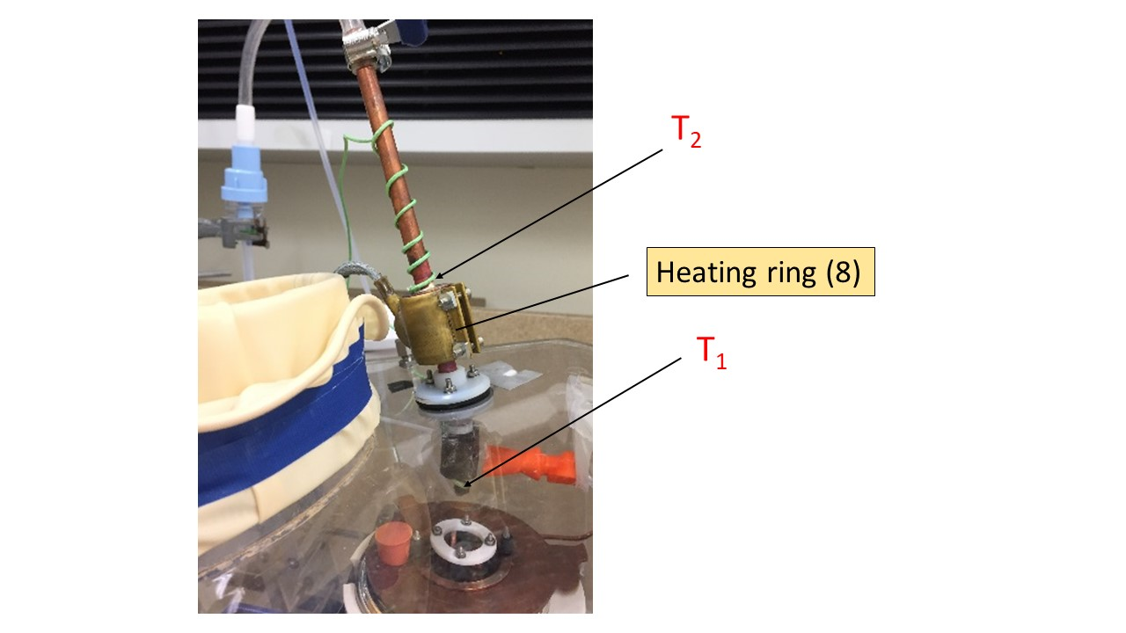

**Figure 5:** Nozzle setup showing heating ring attached around a copper cylindrical block. T1 is K type thermocouple fixed at the bottom of nozzle. T2 is K type thermocouple attached on top of the copper block.

Because the nozzle is close to the liquid ethane level, incoming water droplets may be subject to freezing before entering the cryogen. This poses a problem as crystallization is expected to happen under those conditions. Temperature at the bottom of the nozzle is monitored using a K type thermocouple (T1 in Figure 5) and I aim to maintain this temperature above 0 °C preventing water droplet from freezing.

A heat ring (Voltage) (8 in figure 5) is attached around a 1 cm thick copper block soldered to the nozzle with the purpose to act as a heat sink, warming up the whole copper nozzle. A second K type thermocouple (T2 in Figure 3) is attached to the top of the copper block to monitor its temperature. Both are connected to a PID temperature controller (Red lion). A PID loop allow the voltage of the heat ring to be controlled and adjusted with respect to the inputted copper block temperature. Various experiments have shown that an input temperature of 40 °C for T2 allows the nozzle temperature (measured by T1) to stabilize around 20°C. An alarm has been created such as the temperature of the copper block can`t exceed 50 °C to avoid droplets evaporation. Even though T1 can be below 0°C during the water introduction, no frost is generally observed growing on the nozzle aperture.

Once the time of introduction is passed (20 min), the water reservoir is disconnected from the pipe connecting it to the nozzle. This pipe must then be plugged to avoid releasing ethane gas in the laboratory atmosphere. Reaction vessel height can be lowered down and put aside of the nozzle to avoid remaining condensed water droplets falling into the cryogen. All those steps must be done carefully to avoid big chunk of ice that grew on the heat shield (3 in Figure 1) to fall into the cryogen before the particles have been recovered.

#### Particle recovery

Once the water droplets have been successfully introduced into the cryogen, the next stage in the process involves the recovery of the particles formed. A PTFE membrane (4 in Figure 1) containing 1 μm sized pores screwed to the bottom of a basket made of copper which is used to fish out the particles from the ethane. They will then be dispersed from the basket into a Dewar (DR in figure 1) filled with liquid nitrogen where they will remain stable. Explain why stable in Ln2, and why use of membrane (difference with cryo-SEM).

Figure 6 resume all the experimental steps necessary to recover the particles. First, DR (recovery Dewar) must be filled with liquid nitrogen as previously described. The heat shield is slowly removed, making sure that no frost is scrapped from it during the lift-up by the top of the basket (holding piece). Secondly, the membrane must be lifted-up until it is above the level of the cryogen for the liquid ethane to be drained away from the basket and the ice particles (3) in Figure 6). This step is critical because some time needs to be allowed for the liquid to be drained, but the temperature of the particles is also increasing with time.

The warming curve of a 3 μl water droplet removed from liquid nitrogen at ambient temperature reached -100 ˚C after only 4 seconds (Silvester, Marchese-Ragona, and Johnston 1982), and that is our time constraint to handle the particles out of the cryogen (either ethane or Nitrogen).

I find that the particles obstruct the pores and the liquid ethane is not drained efficiently, also this parameter vary with different experiment. This make the step 4) hardly reproducible and usually resulting in either freezing ethane in liquid Nitrogen or having to wait for a long time for the cryogen to be drained (or evaporated) thus losing the amorphic structure of the particles.

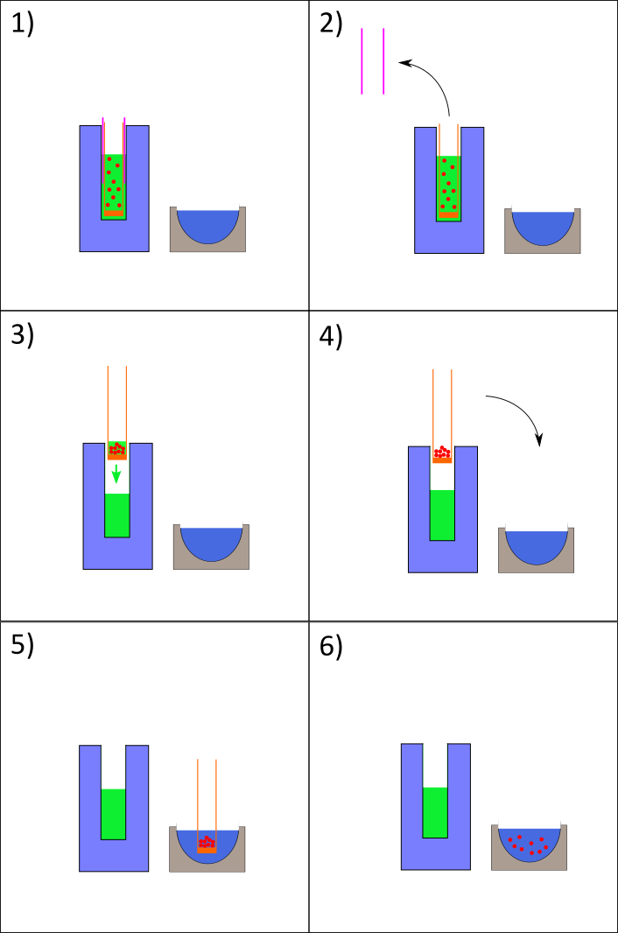

**Figure 6:** Sample recovery experimental steps

However, after dispersion of the basket content within DR (5) in figure 6) we can visually observe that we obtain a milky mixture made of ice particles in liquid nitrogen.

Cleaning 🡪 Ethane is let evaporated while purge on – different pieces cleaned with ultrasonic bath

## 5.4. Testing and preliminary results

2 different sets of experiments have been performed with complementary results. Neutron scattering allow for determination of bulk properties of ice and the surface structure of the particles. Optical microscopy allows for direct imaging, thus determining particles size and size distribution.

### 5.4.1. Neutron Scattering

#### Theory

Neutron scattering is a well-suited non-destructive technique to study the structural properties of materials. Compared to X-Rays, neutrons do not interact with the electronic cloud but with the nucleus of atoms making light atoms such as Hydrogen or Deuterium more visible. We use the ISIS Neutron and Muon spallation source (source) at the Rutherford Appleton Laboratory campus which is a spallation source. The Neutron beam is pulsed, meaning that the neutron energy is determined by the Time of flight (TOF) from the source to the detector, passing through the sample.

The scattering of a neutron by a sample is characterized by a change in its momentum P (wavevector) and Energy E (frequency). In our case, we assume that there is no energy exchange between the neutron and our sample, i.e. that the scattering is purely elastic. It can thus be described by Q, the momentum transfer and is equal to ki – kf where ki is the incident and kf the scattered wavevector. Q can be expressed as:

$$Q= \frac{4π\sin{θ}}{λ}$$

Where θ is the scattering angle and λ the incident wavelength of the neutron.

Neutrons are scattered when their wavelengths are comparable to the distance between objects within the sample. Thus, the larger the wavelength (lambda), the smaller is Q.

We use NIMROD (Near and Inter-Mediate Range Order Diffractometer) (56), a neutron scattering instrument located in the Target Station 2 (TS2) at ISIS, that can measure continuous length scale from 1 to 300 Angstrom. That allows us to probe both the bulk structure at high Q, and the surface structure at low Q as shown in Figure 7



**Figure 7:** Sketch of the Neutron scattering plot showing the different length scale of the sample that can be probed (from Sabrina Gärtner) (to redo)

A neutron scattering experiment measures the number of neutrons scattered in various directions (described by spherical coordinates). This can be expressed by the differential cross section which is the ratio of the scattered neutrons per solid angle unit, divided by the total number of incident neutrons per unit area of beam. The cross section depends on the scattering length of the atom and can be defined as a mean value, the coherent scattering that features all the sample structural information and the incoherent scattering which correspond to a featureless background. The scattering length is isotope specific and Hydrogen has a very high incoherent scattering cross section (80.27 barns) compared to Deuterium (2.05 barns) so H2O will have a low signal on a high background whereas D2O a high signal on a low background. This mean that to obtain a clear neutron scattering signal we need to use D2O to produce our particles at ISIS. (does this modify the resulting cooling efficiency?)

#### Experimental procedure

The whole portable glove box setup is brought at ISIS and the particles are produced in situ following the previously described method (proof of concept) on a workbench close to NIMROD to minimize the time between sample production and introduction into the beam.

4 samples have been prepared with different sets of conditions to test the influence of each`s parameters on the amorphicity of the particles and are resumed in Table 1.

|  |  |  |  |
| --- | --- | --- | --- |
| Sample | Ethane T range (K) | Spraying time (min) | Aspirator purge (mbar) |
| 1 | - | 10 | 200 |
| 2 | 148 - 173 | 20 | 150 |
| 3 | 107- 138 | 30 | 200 |
| 4 | 124-149 | 30 | 500 |

**Table 1:** Experimental parameters used to produce each of the 4 samples at ISIS.

Cell filling method 2 mm TiZr can (3 ml volume) that must be loaded from the top. We poured the mixture of particles in liquid nitrogen into a precooled funnel attached to the can immersed in liquid nitrogen as shown in Figure 8



**Figure 8:** Cell filling method. Recovery Dewar (1) filled with particles in liquid nitrogen is poured into the cell which is maintained at 77K by sitting on Dewar 2, filled with liquid nitrogen (to be redrawn with original files)

The can is then quickly screwed at the bottom of a centre-stick which is then introduced and aligned with the beam. The temperature ramp is controlled by a Closed Cycle Refrigerator (CCR) and span from 100 to 240K to study the structural evolution of the sample and thus constrains the parameter space for future collision experiments on such particles. To account for potential beam loss, the heating ramp is controlled by the amount of data collected in micro-Ampere-hours (μA) which is a measure of neutron flux. This corresponds to an hour in acquisition time as TS2 usually runs on a proton current of 40 μA, meaning that it takes 14 hours of data acquisition for each sample. The pressure inside the vacuum tank of the instrument is setup at 30 mbar of Helium (at approximatively 90K). To obtain a fully corrected and normalized diffraction pattern, it is necessary to make four separate measurements:

a) The sample in a can

b) The empty can

c) A vanadium plate

d) The empty instrument

The raw data which consists of a count of neutrons at each detector is reduced using GudrunN software, a program developed by Soper et al at ISIS (source). Signal is corrected for self-attenuation and multiple scattering as shown in Figure 9.



**Figure 9:** GudrunN Data reduction routine (from C. Hill thesis)

#### Results

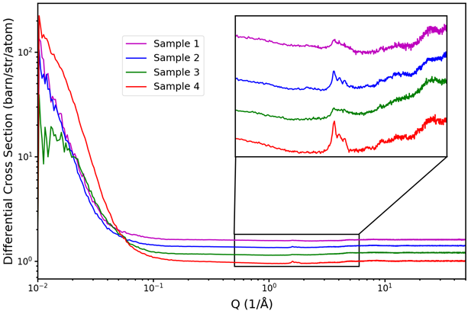

**Figure 10:** Neutron scattering data at 90 K of the 4 samples produced (experimental conditions summarized in table1), the high Q region is highlighted for clarity

To obtain a good match in the DCS level (i.e. the scattering background seen at high Q matches that expected for the given sample composition) in the case of a powder sample, a correction needs to be made in Gudrun to account for the non-complete occupancy of the can by the sample. This is called the tweak factor and it corresponds to the inverse of the filling fraction of the can, which can then be related to the amount of sample inside the can.

The high initial (100 K) tweak factor value (≈ 20) shown in Figure 11, indicates that we have got very few samples into the can. This is something that is confirmed by weighting the TiZr can before and after the experiment. Samples 2, 3 and 4 are respectively weighted at 0.036, 0.035 and 0.032 grams which is way too low to obtain good statistics on a neutron scattering experiment where at least 1g of sample is usually required. The fact that the sample weight is roughly the same for each experiment, despite a different spraying time, indicate that this results from either “the particle fishing method” or the can filling procedure not being efficient.

|  |  |
| --- | --- |
| **Sample 1** | **Sample 3** |
| C:\Users\mwx82498\AppData\Local\Microsoft\Windows\INetCache\Content.Word\sample_1_ethane_amount_moving_average_tweak_factors.png | C:\Users\mwx82498\AppData\Local\Microsoft\Windows\INetCache\Content.Word\sample_3_ethane_amount_moving_average_tweak_factors.png |
| **Sample 2** | **Sample 4** |
| C:\Users\mwx82498\AppData\Local\Microsoft\Windows\INetCache\Content.Word\sample_2_ethane_amount_moving_average_tweak_factors.png | C:\Users\mwx82498\AppData\Local\Microsoft\Windows\INetCache\Content.Word\sample_4_ethane_amount_moving_average_tweak_factors.png |

**Figure 11**: Tweak factor vs temperature Black curves represent the whole sample and blue curve if only D2O is considered

Also, at low temperatures the tweak factor increases exponentially meaning that we have got ethane in the can desorbing until complete evaporation at 140K, which is consistent with ethane vapor pressure at 30 mbar (source). To determine the amount of ethane, we initially processed the data using a pure D2O sample composition. We fitted the tweak factors at T > 140 K as a function of temperature and extrapolated that function to low temperature to determine the likely water amount in the system. We then added ethane to the system and looped to adjust the ethane amount, keeping the water amount fixed, until DCS match was achieved.

|  |  |
| --- | --- |
| **Sample 1** | **Sample 3** |
| C:\Users\mwx82498\AppData\Local\Microsoft\Windows\INetCache\Content.Word\sample_1_ethane_amount_moving_average_ethane_water_ratio.png | C:\Users\mwx82498\AppData\Local\Microsoft\Windows\INetCache\Content.Word\sample_3_ethane_amount_moving_average_ethane_water_ratio.png |
| **Sample 2** | **Sample 4** |
| C:\Users\mwx82498\AppData\Local\Microsoft\Windows\INetCache\Content.Word\sample_2_ethane_amount_moving_average_ethane_water_ratio.png | C:\Users\mwx82498\AppData\Local\Microsoft\Windows\INetCache\Content.Word\sample_4_ethane_amount_moving_average_ethane_water_ratio.png |

**Figure 12**: Ethane amount vs temperature

Despite having very little sample in the beam and thus poor statistics we still performed some analysis which, according to figure 7, is two folded. Firstly, I will present the large angle analysis that highlights the atomistic length scale and thus the bulk structure of the ice and secondly the small angle scattering data analysis that prob the surface structure of the particles.

#### Ice phase

(I am lacking one level of sub-title here (if I keep the 3 level you advised Simon))

The momentum transfer, Q, can probe the interatomic distances within a material, d.

$$Q= \frac{2π}{d}$$

For crystalline samples sharp peaks are produced at higher Q (small distances) and can be related to crystalline structure via Bragg`s law. For hexagonal ice (Ih), a triplet of Bragg peaks is expected at positions 1.59, 1.70 and 1.80 Angstrom-1. The peak at 1.70 will also be found in cubic ice (Ic) (source).

Figure 10 shows the neutron scattering signal I(Q) as a function of momentum transfer Q at 90 K of the 4 samples prepared using the proof of concept experiment whom method has been depicted in section 5.3 with experimental conditions summarized in table 1. The main conclusion of this work is that sample 3 which exhibit the lower ethane temperature range show less crystalline features, and this sample will be our focus for the following discussion. Despite not having good statistics due to the low amount of sample into the cell, a more in-depth analysis has been performed like the method used on a previous work involving ice particles obtained by spraying (from a nebulizer) into liquid nitrogen. (source)

a)

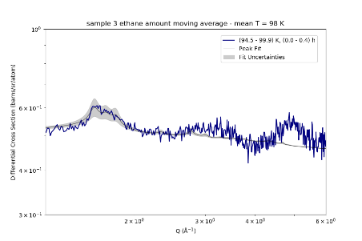

b)

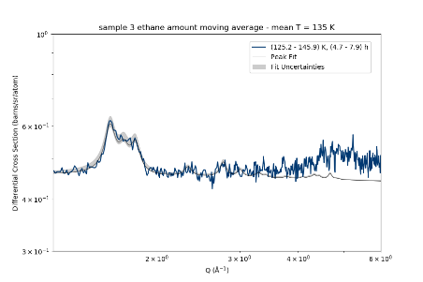

c)

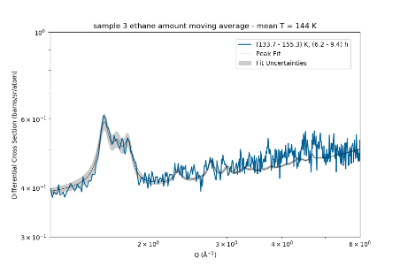

**Figure 13:** Fitting attempt of high Q data of sample 3 at a) 98K; b) 135K; c) 144K;

(the quality of the figure is not great, but I have taken them from a document prepared by Sabrina and I don’t have the code to replot them.)

The signal to noise is low but the asymmetric diffraction pattern is best fitted by hexagonal ice but with smaller crystallites than the particles obtained in liquid nitrogen.

#### Surface structure

To understand the surface properties of our samples, a Porod analysis has been performed to fit the low Q data, cf equation X, where (Δ𝜌𝑖)2 is the scattering length density difference, SSA is the specific surface are and d is the Porod exponent.

Strictly speaking, we have three-component systems: D2O, C2H6, and He. We therefore may have the following interface types: D2O – He (abbreviated DH), D2O – C2H6 (abbreviated DC), and C2H6 – He (abbreviated CH).

The low-Q signal is thus given by the sum of three Porod terms, one for each interface type:

$$I\left(Q\right)= offset+2π\sum_{i}{{\left(∆ρ_{i}\right)}^{2}∙{SSA}_{i}∙Q^{-d_{i}}} , i=DH, DC, CH$$

$${\left(∆ρ_{CH}\right)}^{2}=3.4 ×{10}^{-12} Å^{-4}$$

$${\left(∆ρ_{DH}\right)}^{2}=33.2 ×{10}^{-12} Å^{-4}$$

$${\left(∆ρ_{DC}\right)}^{2}=57.6 ×{10}^{-12} Å^{-4}$$

However, this function has too many parameters and no fitting attempt converged. We have chosen instead to fit a simple Porod function.

$$I\left(Q\right)= offset+2π∙{\left(∆ρ\right)}^{2}∙SSA∙Q^{-d}$$

This assumes that all interfaces have the same structure, hence the same d-parameter. Based on that assumption, the total contrast (Δ𝜌)2 will be a weighted sum of the individual contrasts for each interface type, as shown in the plot below.

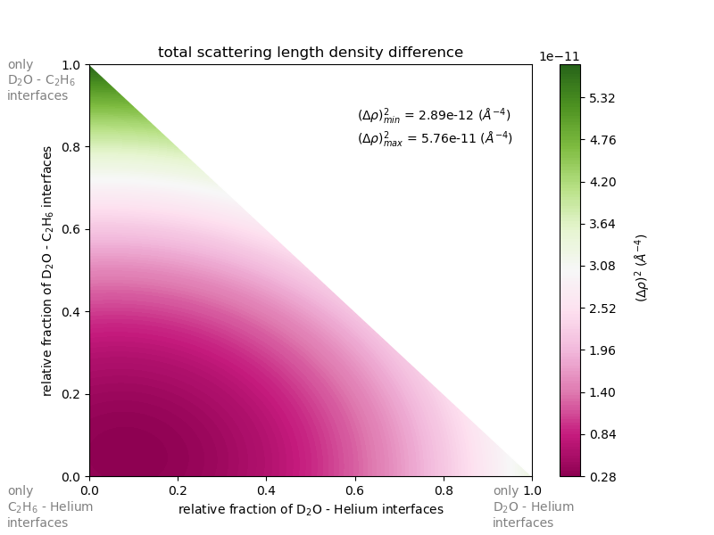

**Figure 14:** Total scattering length density differences for the different interfaces present in our samples (from Sabrina Gärtner)

The derived SSA depends on the value chosen for the contrast. We have chosen that to be the contrast of D2O, meaning that at high T, where ethane is gone, the derived SSA will be meaningful. We have run the analysis on all 4 samples, although samples 1 and 2 show too few signals at low-Q to allow reliable fitting at any temperature.

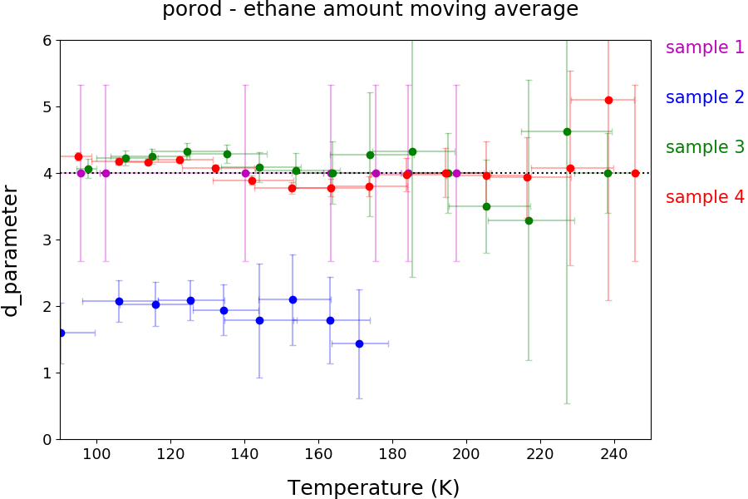

**Figure 15:** Porod exponent, d, vs temperature

At low temperature, d is above 4, which mean that we have got a contribution from diffuse interface. As (Δ𝜌𝐶𝐻)2< (Δ𝜌𝐷𝐻)2< (Δ𝜌𝐷𝐶)2, the main contribution at low T must be from C2H6 – He interfaces, meaning that ethane forms a diffuse surface layer around our particles.

However, at T > 140K, when ethane has desorbed, d drops to 4 or slightly below, indicating smooth or slightly rough, sharp interfaces.

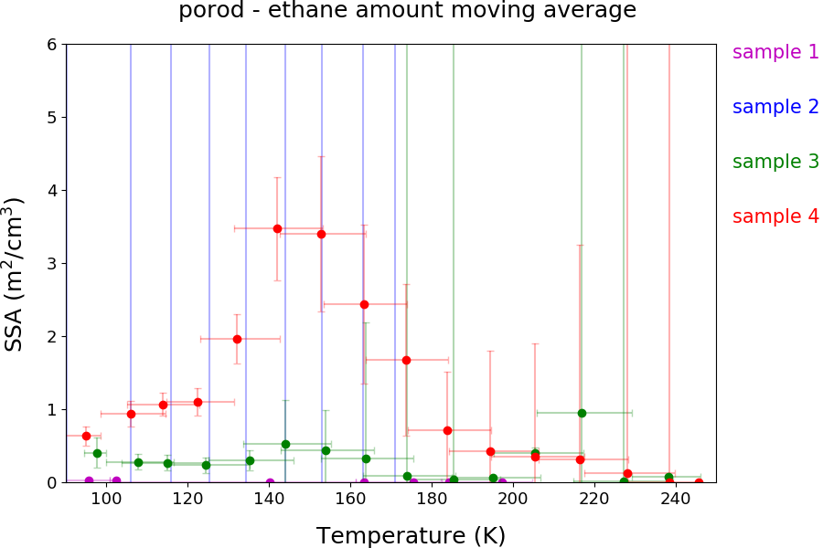

**Figure 16:** Specific surface area vs temperature.

Comparison between samples 3 and 4 shows higher SSA for sample 4, however, the fitted value of d strongly influences the best fitting SSA and the high fitting uncertainties prevent further conclusions in the SSA.

### 5.4.2. Optical microscopy

#### Experimental procedure

To directly observe the particles, we use an optical microscope that features a plate, cooled by liquid nitrogen. However, the introduction of the particles is challenging and has required a specific design in collaboration with the OU workshop shown in Figure 17. The microscope is introduced in a glove bag, which is purged with dry N2 gas preliminary to the cooling of the plate to avoid the accumulation of frost on the cold parts. A picture of a μm scale is taken and the copper cell (c), preliminary cooled in liquid nitrogen is placed on the cold plate using tweezers. The particles in liquid nitrogen are directly introduced from the recovery Dewar into the cell using a funnel (b). Focus and light are adjusted in real time and pictures are taken from a camera controlled by a computer. Some pictures will be shown in Figure 18.

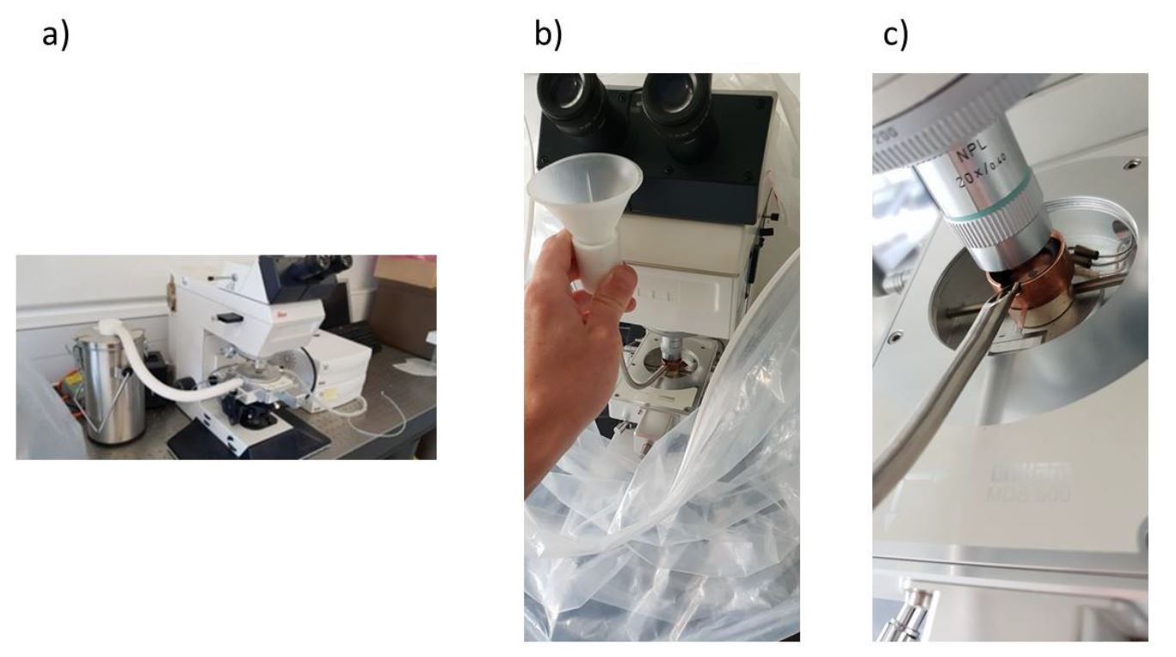

**Figure 17:** a) microscope setup b) cell filling method c) close view of the copper cell

#### Results

Figure 18 shows pictures taken with the previously described microscope setup, of ice particles produced in liquid nitrogen using different N2 pressure through the nebulizer. picture a) has been obtained from particles produced at a flow of 0.5 bar (blue in figure d) and picture b) with a flow of 0.2 bar (orange in figure d). Using ImageJ (source), an image processing software, we can track and determine the size of each particle (147 for experiment a) and 643 for experiment b)) over a range of images and thus derives a particle size distribution for each experimental condition shown in Figure 18 d).

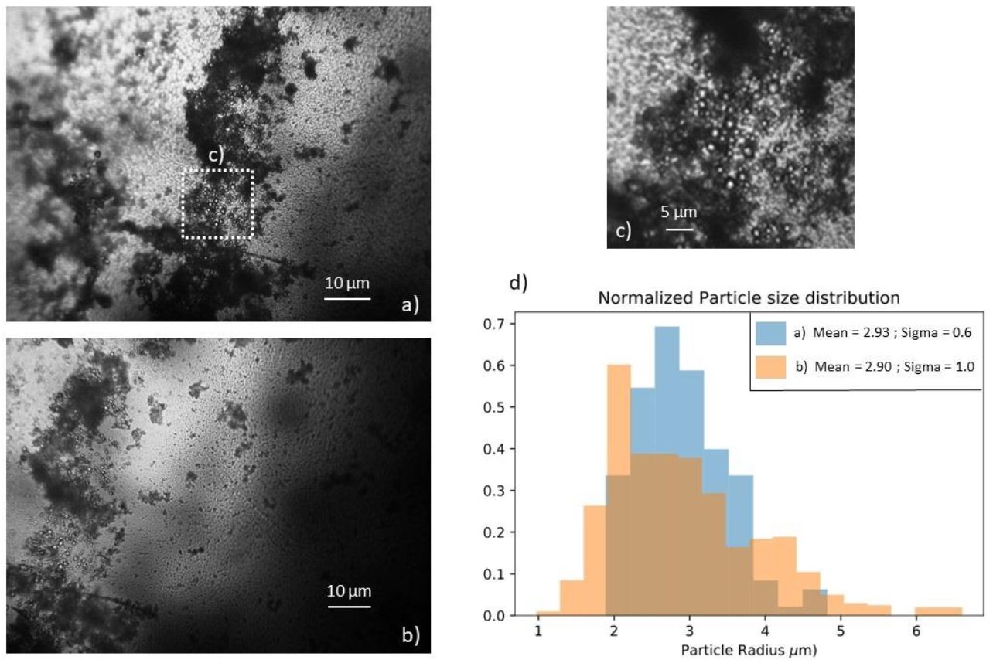

**Figure 18**: a) particles pictures: N2 flow 0.5 bar b) particles pictures: N2 flow 0.2 bar c) zoom section of picture a) d) Normalized particle size distribution.

(I will redo this figure with only pictures first and a second with the size distribution – would have been great to perform more experiment with this technique, and the new setup (that was planned actually w/ Tom Giulia Julia) but not sure this will be possible)

I observe that varying N2 flow does not alter the mean value of the particle size (2.9 μm). However, a higher dry N2 flow through the nebulizer reduces the size dispersion (+- 0.98 for 0.2 bar / +- 0.62 for 0.5 bar).

It is my intention in the future to take pictures of the particles using a Scanning Electron Microscope (SEM), to resolve the individual particles and how they interact with each other.

## 5.5. Discussion and limitations

(more work needed)

This proof of concept experiment has demonstrated that we can safely produce and use liquid ethane. Progress needs to be made enable simplifying the liquefaction process and make it more reliable by being able to control and monitor the ethane temperature.

The water droplet production and introduction has proven to be efficient and reliable.

However, lots of condensation on pipes wall and droplet formation on the nozzle orifice.

The particle recovery, however, remains a challenge along with the separation of the ice particles from the cryogen.

Next is result section highlighting some of the challenges and requirement when handling cold metastable sample.

# 6. 2nd Version, Hardware Development

Implementing the lessons learned from the proof-of-concept phase, we have built a second-generation experiment to address the previously described challenges. The process remains similar, cooling a Reaction vessel made of copper to liquefied gaseous ethane in which µm sized water droplet will be introduced aiming to produce HGW particles. The previous experiment required a lot of manipulations within the glove box during the cooling phase and we have thus designed this novel setup to minimize interventions from ourselves and thus making it safer and more reliable. Additional safety features include the fitting of a pressure gage to monitor any over-pressurization within the glove box. A proportional relief-valve with a burst pressure of 0.2 bar has also been implemented.

## 6.1. Overall Design

A new glovebox made of polycarbonate (good resistance to cold temperature), has been bought enabling a bigger volume (Dimensions?) and is presented in Figure 5. Two major improvements have been implemented.

First, the reaction vessel (1 in figure 5) is no longer cooled by submersion in liquid Nitrogen but by an open cold N2 gas flow passing through a solenoid copper pipe in contact with the copper Reaction vessel. Liquid Nitrogen is channeled to the Glove box via a PTFE flange (2 in figure 5) from a pressurized Dewar (200L). The temperature is control and adjusted by using a 20W power heating wire attached between the pipe interstices and connected to a PID controller.

Secondly, we decided to abandon the membrane “fishing method” and to recover the particles within the liquid ethane, thus reducing the level of manipulation and consequently modification of the particles.

Intermediate step for further separation (Link with XP Part II 🡪 recover particles in acoustic trap and evaporate ethane using low pressure)

A cryogenic ball valve (6 in Figure 5) has been installed at the bottom of the reaction vessel for that purpose and different recovery setup can be installed beneath the reaction vessel for various sample handling and storage method, increasing experimental versatility. A recovery nozzle is screwed downstream the valve and can be interchanged

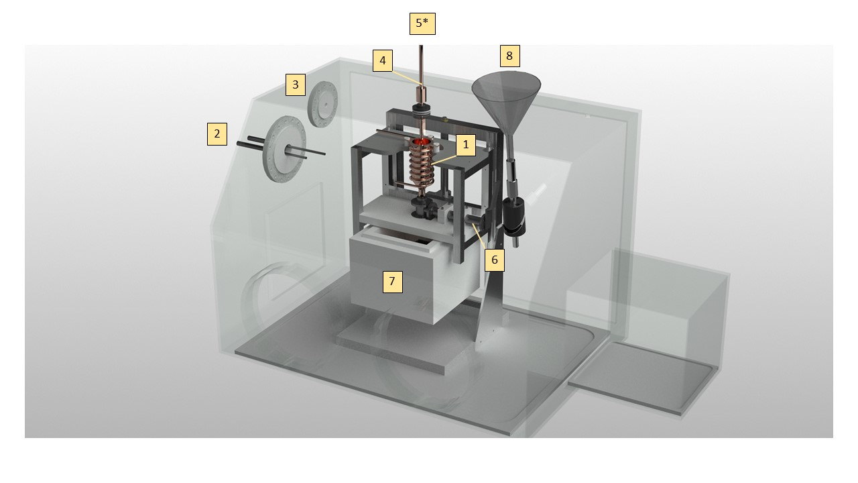

Figure 19 Glove box setup. numbers will be explained in the text

**1.** Reaction vessel with integrated copper tubing around outer wall. The pipe is silvered soldered to the copper vessel in order to achieve a maximal thermal transfer. Between the pipe interstices is attached by Kapton tape a heating wire (reference) directly connected to a PID controller (Lakeshore model 335). 2 T type thermocouples are attached to the Reaction vessel (cf. Figure 7 for thermocouple setup) in order to precisely control it temperature, allowing for (a) ethane liquification and (b) amorphous ice formation.

**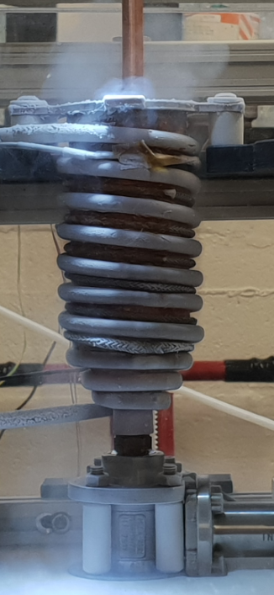**

Figure 20 Reaction vessel

**2.** 1 cm thickPTFE Flange featuring liquid Nitrogen feedthrough CF-40 (MDC Vacuum 9812105). Inlet is connected to a pressurized Deware (200L) and connected to Reaction vessel piping by a corrugated hose. Flexible tubing (e in Figure 7) allow the reaction vessel to move up and down by more than 10 cm and to adjust its position with respect to the Nozzle or to the sample recovery area.

**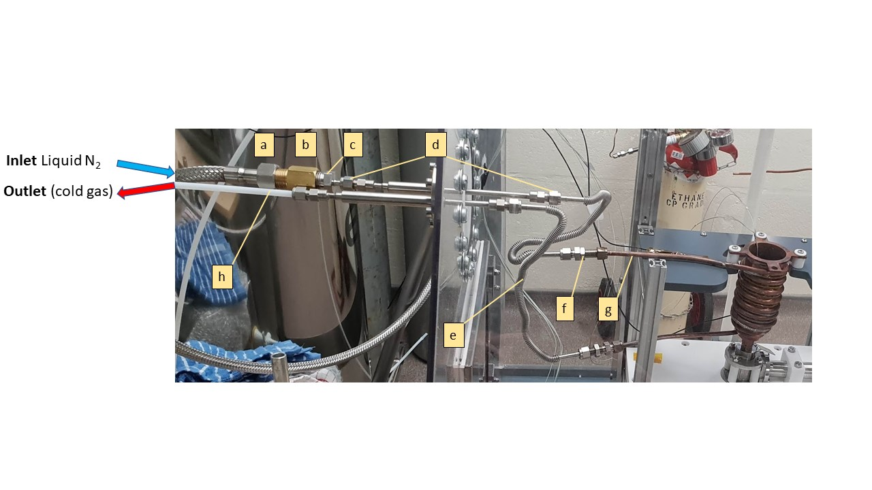**

Figure 21 Liquid N2 PTFE flange setup **[a]** cryogenic hose ½“ BSP , **[b]** ½” male to female adapter, **[c]** Male tube adaptor ¼” tube OD \* ½” (Swagelock SS-4-TA-1-8), **[d]** Swagelock tubing connection ¼” , **[e]** Stainless steel flexible tubing ¼” OD (Swagelock 321-4-X-12-B2), **[f]** Bulkhead union ¼” OD (Swagelock SS400-61), **[g]** Copper tubing ¼” OD, **[h]** PTFE tubing ¼” OD,

**3.** PTFE Flange for electrical equipment; One Thermocouple feedthrough (6 \* T type) and the heating wires (cf. Figure 9).

**4.** Nozzle featuring copper block heating ring attached. Prevents water freezing in nebulizer and/or line from water reservoir. Controlled via PID controller and attached thermocouples.

**5.** Nebulizer inlet. Reservoir of deionized water and/or D2O connects though this port, pressure is provided by dedicated nitrogen cylinder secured in lab to deliver water into copper vessel [5] as a fine mist through the nebulizer.

**6.** Valve attaching to base of reaction vessel. Rated for operation with cryogenic materials/environments.

**7.** Release point for material in copper vessel [1] when valve [6] is opened

**8.** Funnel port. Valve at base of funnel isolates this port from the inside of the chamber during normal operation. It can be opened to allow addition of liquids, e.g. small amounts of liquid nitrogen to a Deware if/as required. Could also serve as back-up for pressure-relief-valve.

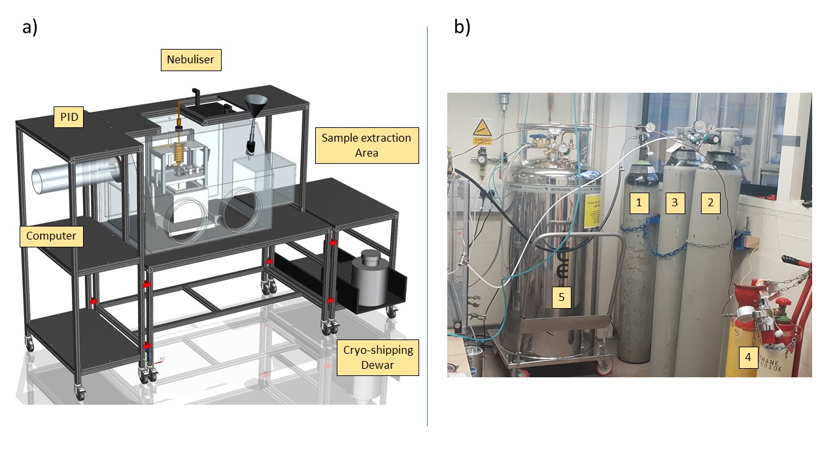

Figure 22 Overall setup a) BOSH Design b) Gas setup

* XP transportable and self-contained
* Designed to minimize time between sample extraction and storage

1 -3 Are Nitrogen gas bottles. 1 is 0 grade and connected to the nebulizer via a custom fitting. 3 is connect via ¼ “piping to both the main and the airlock chamber of the Glove box for purging. The experiment can be long and another full bottle (2) must be present to ensure that the purge will be on at all time. 4 is the ethane bottle. 5 is a pressurized liquid Nitrogen Dewar connected to the cooling circuit via a cryogenic hose. A protection has been put in place to avoid to much condensation on the cold surfaces outside the glove box, but frost is unavoidable.

### 6.2.1. Temperature control and recording

#### Cooling

Liquid nitrogen cool reaction vessel, warm up, transform to gas (expansion ratio 1:694 ) and is extracted through PTFE flange into a Deware (to recover liquid if any). Lot of Nitrogen is released into the atmosphere that need to be well ventilated. The lab needs also to have proper Oxygen alarm. Even with very long experiment, no liquid Nitrogen has been recovered into the Dewar.

The flow of Nitrogen passing through the pipe is a parameter difficult to monitor and thus to control. It could have been monitored using a flow meter connected to the exhaust, but this is not feasible as no flow meter are currently rated for use at cryogenic temperature. However, it is possible to obtain a visual information about the flow rate. Despite nitrogen being a transparent gas, when cold enough it can produce a fog due to condensation of ambient water droplets from the lab, like cloud formation in the atmosphere (to be explained much better !!).

This phenomenon allows us to get a quantitative information about the Nitrogen flow as depicted by Figure 9.

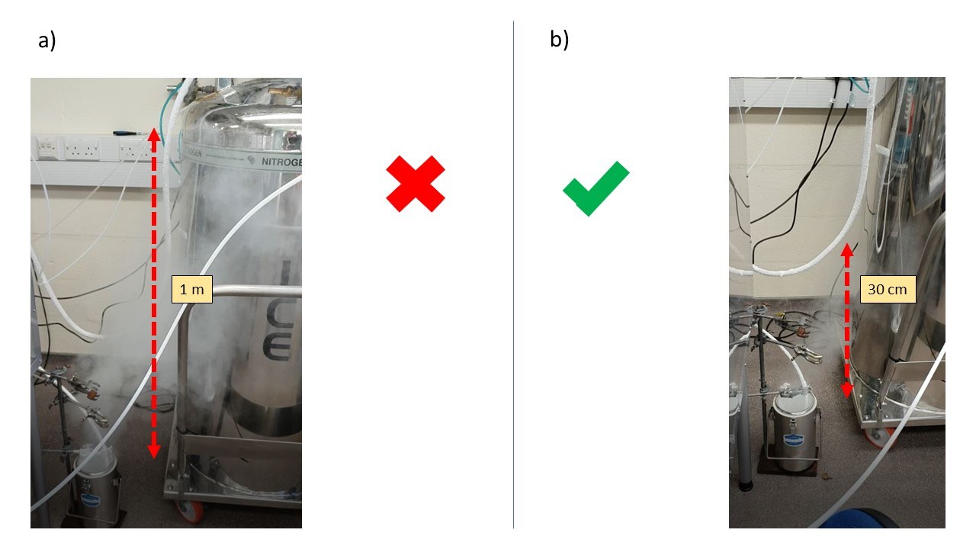

Figure 23 Liquid Nitrogen exhaust setup.vRed arrow describe … a) Liquid Nitrogen flow too important b) Adequate Liquid Nitrogen flow

2 parameters are important to control the Nitrogen flow. The base pressure of the cryogenic Dewar and the valve opening percentage (cf Figure 14 b). The cryogenic pressure is usually set up by the fabricant. It can be tuned by modifying the bursting pressure of the pressure relief valve fitted on all those Deware but the pressure take time to build up and is not suitable for fine tuning on the fly as required by the experimental procedure.

So I have to use the opening of the valve as the adjustable parameter for the Nitrogen flow variable. Very fine tuning … Not consistent all along the experiment …

#### Warming up and Temperature control

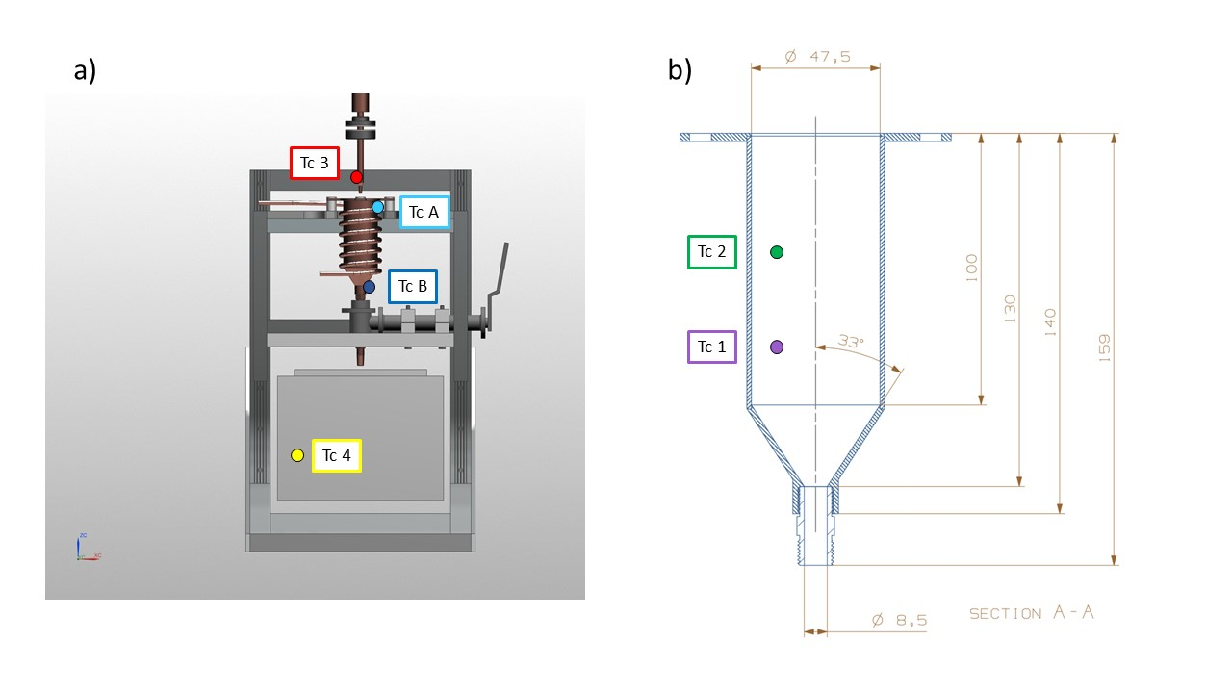

Figure 24 Thermocouple setup a) outside the reaction vessel, b) inside reaction vessel

Temperature measurement within the glove box is performed using T type thermocouples (Cu\Cu+ Ni), rated for constant use at temperature between -200 to 350 °C.

They represent the best thermal sensor for our purpose because cost effective, strong and versatile in usage and because very high precision is not required.

The inner (within the glove box) end of the metallic wires has been spot welded to create the measurement junction. 6 thermocouples are channeled through the glove box via the same feedthrough, ATEX certified (Ex II 2 GD, Ex d IIC Gb / Ex e IIC Gb, Ex ta IIIC Da) for use with vacuum and pressurized system but more importantly certified to work under explosive atmospheres.

Tc A and Tc B (light and dark blue in Figure 9) are attached with Kapton tape at the top and bottom of the reaction vessel and are connected to a Lakeshore PID (model 335). It is important to have two thermocouples at different places on the reaction vessel to measure the differential cooling efficiency from the liquid nitrogen flowing through the copper pipe

A simple Labview code allow the control of TCB temperature by applying a voltage to the heater. (Why TCB – description of Labview code)

TC 1,2,3,4 are attached to a Picolog TC-08 and are recorded separately from TCA and TCB.

TC1 and TC2 are attached to the frost shield at different depth to measure any temperature gradient variation within the cryogen.

TC3 is attached to the nozzle in order to prevent frost formation.

TC4 is a flying thermocouple that we can move to monitor the temperature within different area of the glove box. It is used to record different piece of equipment involved in the sample recovery and transfer procedure.

2 different software used to record the temperatures (Labview, to work with Lakeshore TCA and TCB) and Pico log software for TC1, 2, 3, 4. To be described ?

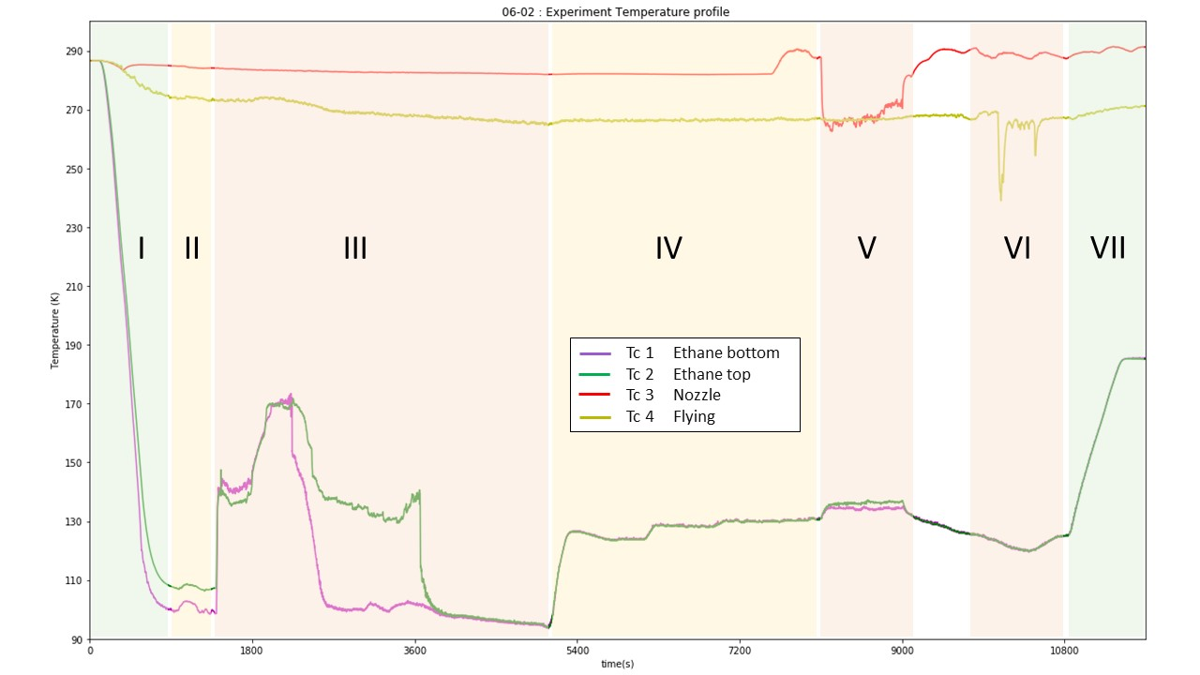

Figure 25 Experiment temperature profile. The different number refer to each experimental step : I. Reaction vessel cooling; II. lN2 flow reduction; III. Ethane introduction/liquefaction; IV. Temperature setting; V. Water introduction; VI. Sample recovery; VII. Ethane warm up/evaporation. Color refer to the level of manipulation needed for each phase, green: not much to do, red: lot of manipulation needed.

|  |  |  |  |  |
| --- | --- | --- | --- | --- |
|  | **name** | **duration** |  |  |
| **I** | Cooling |  |  |  |
| **II** | Flow adjustment |  |  |  |
| **III** | Ethane liquefaction |  |  |  |
| **IV** | Temperature setting |  |  |  |
| **V** | Water introduction |  |  |  |
| **VI** | Sample recovery |  |  |  |
| **VII** | Warm up / close up |  |  |  |

Table 2 Experimental steps along the procedure

Figure 10 represent the temperature evolution of TC 1-4 for a typical experiment. The first phase corresponds to the cooling of the Reaction Vessel. 15 minutes are enough to cool the Reaction vessel (Abbreviation) to its base temperature (around 100K). TCA and B are not shown on this diagram for clarity, but a more precise cooling curve is shown in Figure 12. In order to match with the low power of the heater the N2 flow needs to be reduced at the minimum and that is achieved during the second phase. The third step is the ethane liquefaction who is characterized by a steep increase in both inner temperature TC1 and TC2. Consequently, the temperature show a steep decrease when the thermocouple are immerged by the cryogen (TC1 first and then TC2). The phase IV correspond to the time period where the ethane is set up within the desired range prior to the water introduction (V). VI correspond to the sample recovery and VII to the boiling off the ethane and the shut down procedure.

### 6.2.2. Water droplet production

Similar but care has been taken to control and minimize pipe length to diminish droplet condensation on the pipe walls. Also, nozzle is straight

Distance heater - nozzle end.

### 6.2.3. Sample recovery method

Because the sample is recovered from the bottom of the reaction vessel an empty space area has been designed below the reaction vessel (roughly 10\*10\*10 cm), allowing different sample recovery setup to be put in place. 2 method have so far been developed. One that allow filling in 1 ml cryo-vials with ice sample embedded into the cryogen to be stored in a cryoshipping Dewar (reference). The other method has been developed jointly with ISIS Neutron and muon source in order to fill a Vanadium square cell, necessary to perform Neutron scattering experiment.

#### Sample storage

(Picture of sample holder with vials).

A metallic sample holder designed to hold the vials is inserted into a polystyrene box. Liquid Nitrogen is filtered and introduced through funnel (8 in Figure 5) into the polystyrene box.

#### ISIS cell filling

(diagram + picture of the setup)

Vanadium foil + 1 or 2 mm spacer –

Copper block – long time to cool – Heat sink

Funnel made of spacer hold together by Aluminum tape.

Ethane drained through lose junction between cell and funnel.

Bucket to recover the remaining ethane.

## 6.3. The cooking recipe to produce HGW µm ice particles

### 6.3.1. Warm-up and Glove Box purging

All material putted in the glove box 🡪 nice and clean working space

Check integrity of system, thermocouple attachment …

Back panel of glove box screwed in place

Nitrogen purge 1h, stopped when the Oxygen level reach a plateau (1%). No explosive atmosphere and most of residual water removed from the glove box 🡪 use of dessicant, calcium carbonate, not that efficient … but tackled by having “cold spot” away from the reaction vessel 🡪 cold trap. Capture some of the water molecules but frost remain a big issue.

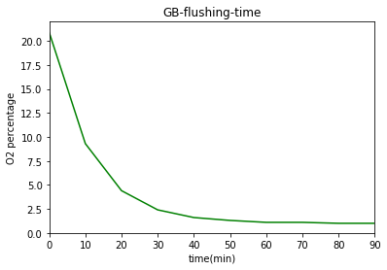

Figure 26: O2 percentage vs time with Nitrogen flow 0.2 bar

### 6.3.2. Reaction vessel cooling

2 temperature recording software (Labview and Picolog) are started (t = 0) and the valve on the Pressurized Deware is open (2C) 1 minute later.

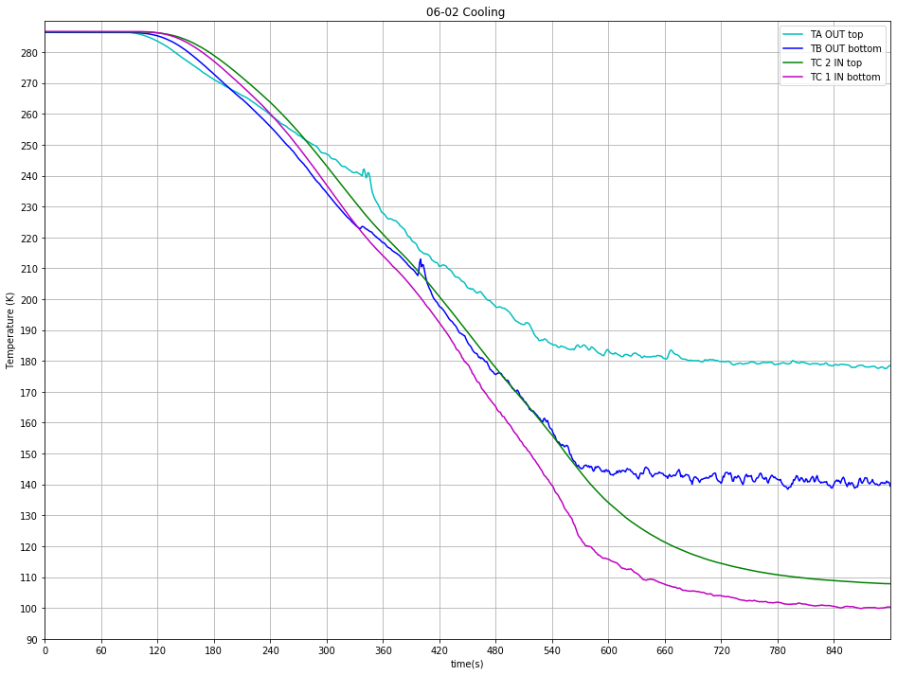

Figure 27 Typical cooling curve

As described earlier the valve opening is key to control Nitrogen flow through the pipe.

Various experiment with different valve opening percentage have been performed and show that the maximum cooling is achieved at 2C (cf Figure 14 b) and that a further opening doesn’t improve the cooling efficiency.

Cooling curve comparison (could have been good to have a comparison of each TC with increasing valve opening but data unexploitable …)

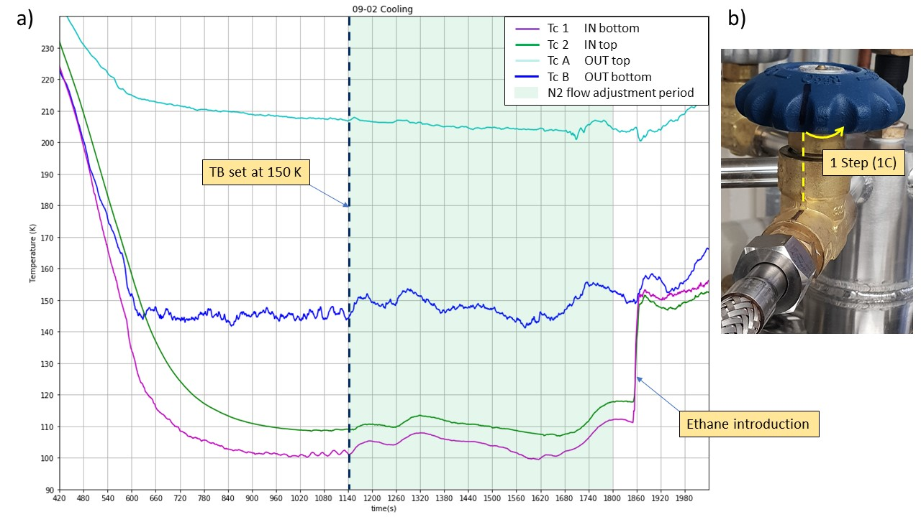

Figure 28 Flow adjustment period

After Reaction vessel has reached base temperature The Nitrogen

Deep care needs to be taken to control and adjust this parameter all along the experimental procedure as it can randomly vary. A liquid Nitrogen flow set up too high won’t allow the Heater to work properly.

### 6.3.3. Ethane liquefaction

Once the Liquid Nitrogen flow has been adjusted correctly (as low as possible), gaseous ethane can be introduced. The ethane pipe inside the glove box (downstream to valve?) must be placed inside the Reaction vessel (cf. Figure 15) whose height can be adjusted to allow an immersion of the pipe around 2 to 3 cm inside the Reaction Vessel. Ethane flow is started by opening first the valve ? on the ethane cylinder and valve ? located on the glove box. This will result in the apparition of a fog (micro particles of solid ethane?) shown in figure 15 a) and b). Ethane flow is monitored by a digital pressure gage located downstream the regulator attached to the ethane gas cylinders. A pressure too important will result in a turbulent fog (Figure 15 a)) resulting in a loss of material. Consequently, to improve the liquefaction efficiency, the ethane flow is progressively reduced to obtain a steady introduction (Figure 15b)). It is usually obtained for a pressure around 80 mbar.

This phase is marked by a steep increase in TC1 and 2 temperature, due to the introduction of a hot gas within the reaction vessel. The first 10 minutes of introduction required a lot of attention, time for the system to reach an equilibrium (explain more).

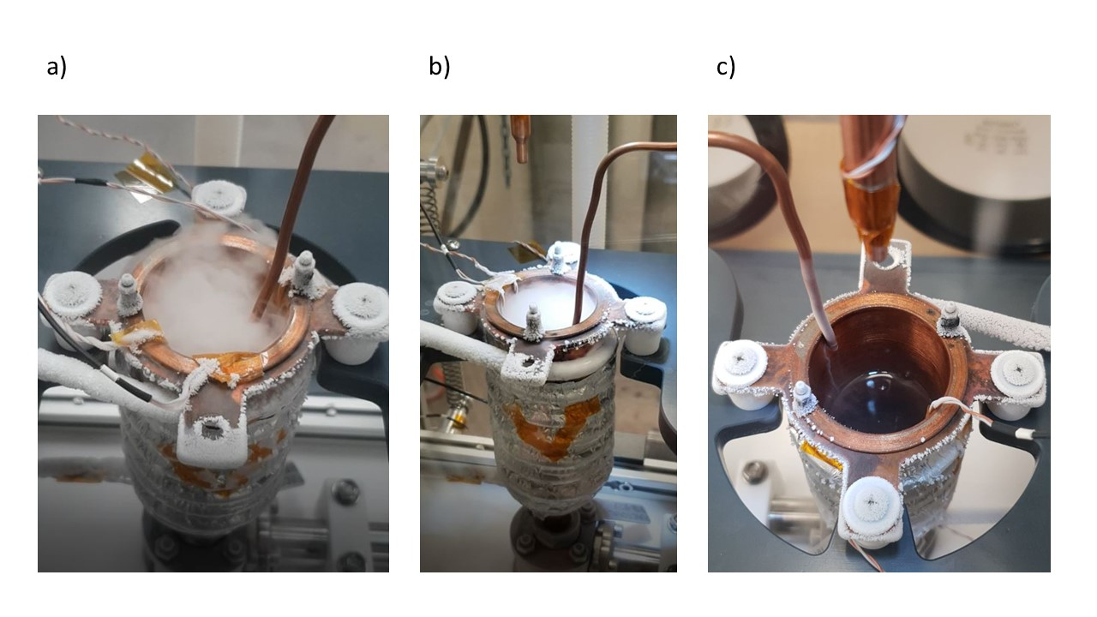

Figure 29 Ethane liquefaction

With optimal conditions (look for data), high temperature / high ethane flow, gaseous ethane is directly converted into a liquid and the fog disappear (Figure 15 c)). This allow a direct monitoring of the speed of the liquefaction process. Otherwise we can rely on the Thermocouple data to monitor it. An important decrease in TC1 and TC2 temperature arise when they are submerged by the liquid.

* Calculation Volume of liquid per time 🡪 liquefaction speed (comparison …)

TC1 and TC2 have same temperature 🡪 no thermal gradient at different height 🡪 good

Frost growing on cold temperature experiment part (corrugated hose …) but not on reaction vessel, cold trap preventing frosting of critical areas.

Speak about when temperature high enough, no fume produced.

Once enough ethane produced (3cm to the top)🡪 volume. Monitored by graduation engraved on Frost shield. Close the valve, ethane bottle first and then the valve on the glove box.

Stop of ethane introduction (hot gas) usually result in temperature decreasing, the system needs some time and manipulation to find an equilibrium state.

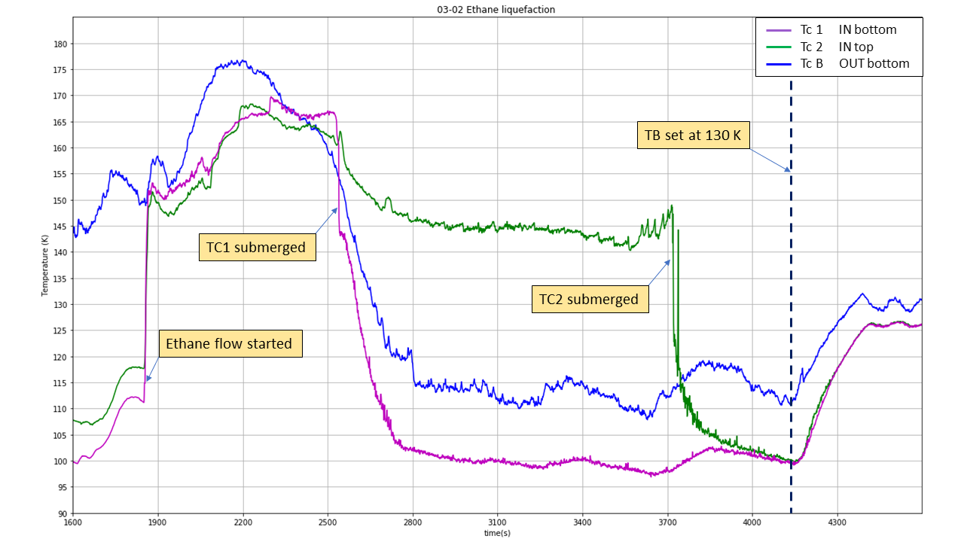

Figure 30 Ethane liquefaction

### 6.3.4. Ethane Temperature control

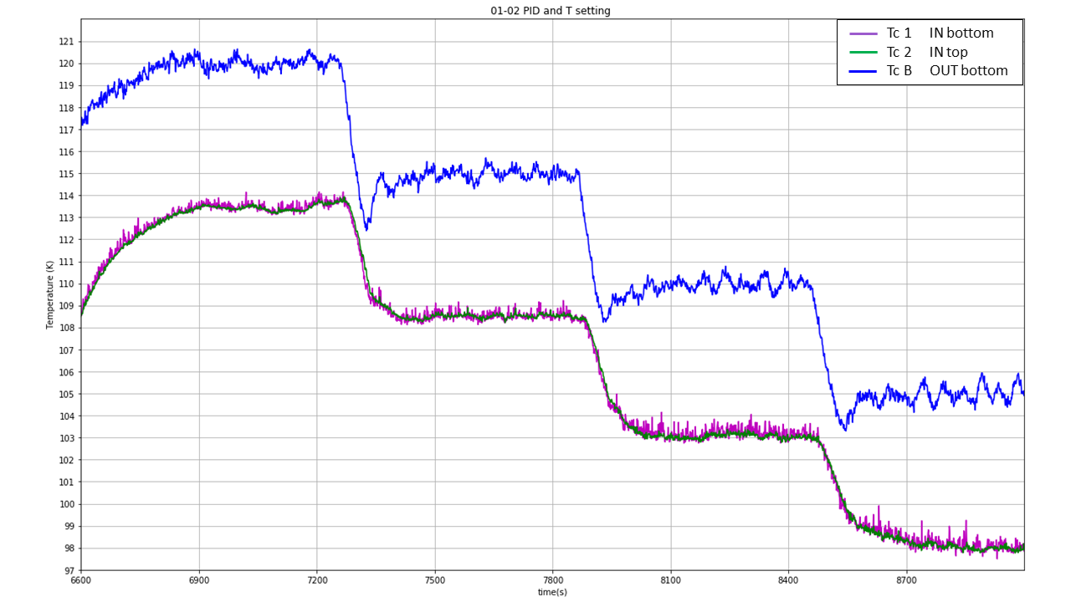

Figure 31 Temperature setting

PID settings:

TCB used 🡪 more reliable

### 6.3.5. Water introduction

The water droplet introduction phase is relatively similar to the procedure used on the previous proof of concept experiment. First the water reservoir has to be filled with the required amount (10 ml) of deionized water and the top screwed tightly in place.

The nebulizer compressor is connected to a 0 grade Nitrogen bottle whose pressure is set up to 0.5 bar. Then the Nebulizer is turned on and this will result in the production of a fine mist of µm droplets.

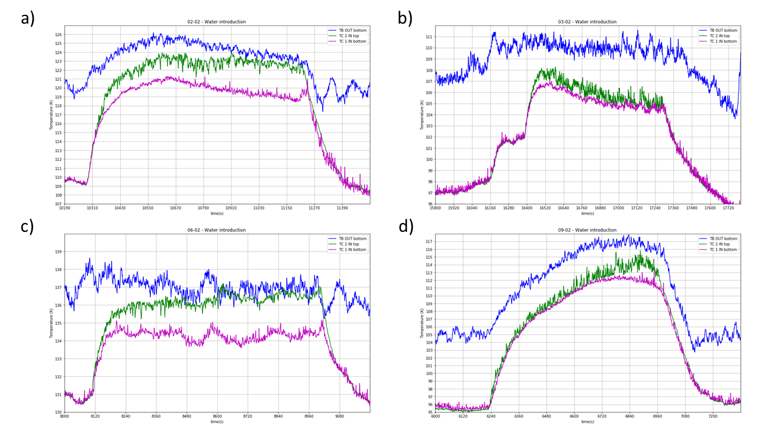

Figure 32 Water introduction ethane temperature

The introduction of a hot (20 °C) mixture of gas and water droplets result in an increase of the ethane temperature. TC2 equilibrate higher than TC1. Temperature difference differ with different experimental procedure (base temperature …).

Water droplet production required a full attention of the operator in order to avoid big droplets forming by condensation on the on the nozzle to fall into the cryogen. Such droplets are constantly forming and are cleaned by absorption from a Q-tip.

### 6.3.6 Ice recovery

#### Sample storage

#### ISIS cell

Both required use of heat sink to maintain a temperature well below the glace transition of water (137K). Liquid Nitrogen is used to cool down the heat sink. Liquid Nitrogen is filtered and poured through funnel (8 in Figure 5) into a Dewar and then introduced into the sample recovery setup chosen.

🡪 Time consuming and heavy manipulation task. Must be started during equilibrium phase of ethane liquefaction and temperature adjustment phase. Lots of Nitrogen evaporating during cooling, has an impact on overall temperature within glove box (can reach -10 degrees). Make working conditions more difficult.

## 6.4. Discussion and evaluation

Improvement

* Increasing N2 gas flow going through nebulizer
* Anti water condensation coating to prevent condensation
* May be use an appropriate nozzle (cf different spray geometry) 🡪 What minimum sizes can we achieve
* Test nozzle + nebulizer flow by spraying with different experimental parameter (pressure) and see penetration depth into liquid with same viscosity as liquid ethane (paraffin oil ?)
* Introduce some dust to create a proper Interstellar dust analogue
* Find a way to stir and mix the ethane (wider diameter for RV)
  + Gear system (no electrical equipment)
  + Create a syphon (kind of) 🡪 Highly convective system, brough the particles at bottom of RV, Reduce temperature increase due to water introduction
* Vary the cryogen, for example mixture of ethane + propane
  + 🡪 Lower the boiling point

(Tivol, Briegel, and Jensen 2008)

# Bibliography

Angell, C. A., and Y. Choi. 1986. ‘Crystallization and Vitrification in Aqueous Systems’. *Journal of Microscopy* 141 (3): 251–61. https://doi.org/10.1111/j.1365-2818.1986.tb02720.x.

Bachmann, L., and W. W. Schmitt. 1971. ‘Improved Cryofixation Applicable to Freeze Etching’. *Proceedings of the National Academy of Sciences* 68 (9): 2149–52. https://doi.org/10.1073/pnas.68.9.2149.

Bar-Nun, Akiva, and Diana Laufer. 2003. ‘First Experimental Studies of Large Samples of Gas-Laden Amorphous “Cometary” Ices’. *Icarus* 161 (1): 157–63. https://doi.org/10.1016/S0019-1035(02)00016-7.

Brüggeller, Peter, and Erwin Mayer. 1980. ‘Complete Vitrification in Pure Liquid Water and Dilute Aqueous Solutions’. *Nature* 288 (5791): 569–71. https://doi.org/10.1038/288569a0.

Dubochet, J., and A.W. McDowall. 1981. ‘VITRIFICATION OF PURE WATER FOR ELECTRON MICROSCOPY’. *Journal of Microscopy* 124 (3): 3–4. https://doi.org/10.1111/j.1365-2818.1981.tb02483.x.

Le, Hai, Yi Liu, and M. Sam Mannan. 2013. ‘Lower Flammability Limits of Hydrogen and Light Hydrocarbons at Subatmospheric Pressures’. *Industrial & Engineering Chemistry Research* 52 (3): 1372–78. https://doi.org/10.1021/ie302504h.

Lebrun, P.P.H. 2000. ‘A Review of the Technical Aspects of Drug Nebulization’ 22: 7.

Mayer, Erwin, and Peter Brüggeller. 1982. ‘Vitrification of Pure Liquid Water by High Pressure Jet Freezing’. *Nature* 298 (5876): 715–18. https://doi.org/10.1038/298715a0.

Silvester, N. R., S. Marchese-Ragona, and D. N. Johnston. 1982. ‘The Relative Efficiency of Various Fluids in the Rapid Freezing of Protozoa’. *Journal of Microscopy* 128 (2): 175–86. https://doi.org/10.1111/j.1365-2818.1982.tb00449.x.

Tivol, William F., Ariane Briegel, and Grant J. Jensen. 2008. ‘An Improved Cryogen for Plunge Freezing’. *Microscopy and Microanalysis* 14 (5): 375–79. https://doi.org/10.1017/S1431927608080781.

Turnbull, David. 1969. ‘Under What Conditions Can a Glass Be Formed?’ *Contemporary Physics* 10 (5): 473–88. https://doi.org/10.1080/00107516908204405.

Wang, H., R. C. Bell, M. J. Iedema, A. A. Tsekouras, and J. P. Cowin. 2005. ‘Sticky Ice Grains Aid Planet Formation: Unusual Properties of Cryogenic Water Ice’. *The Astrophysical Journal* 620 (2): 1027–32. https://doi.org/10.1086/427072.